** Call for Artists **

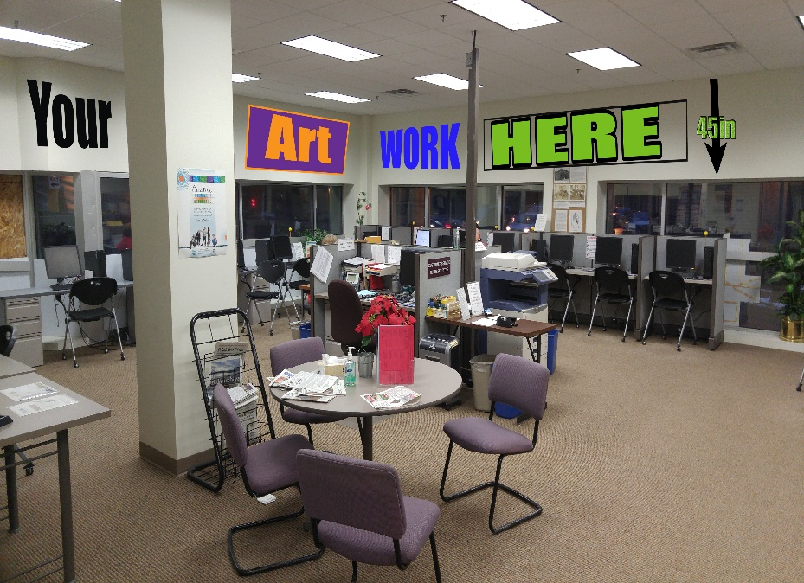
Opportunity Opens
4/12/17

Opportunity Closes
4:30 PM on 5/5/17

Application Email:
nlsmith@duluthmn.gov
IMportant Dates

Are you looking for a new way to feature your art work? The Duluth Workforce Center, located downtown at the intersection of 1st Street and 4th Avenue West, is the One-Stop employment and training resource for individuals seeking employment and employers looking for qualified workers. In an effort to create a space that is more reflective of our community and welcoming to all who utilize the Center, we are extending a call for artists to display their work in this public domain on a rotating basis.

We are looking to showcase 8 to 10 different pieces total, depending on size. We have approximately 32 feet of wall space available for art works of different types (canvas, photography, drawing, etc.). The height of the space is 45 inches and expands around the room above the computer workstations as shown in the picture above. We would also like to include an informational place card that highlights the artist's name, name of piece/s displayed, and a brief background on both.

This is the Workforce Center’s first art display and while we are not able to display artist’s pieces for sale at the Workforce Center, this is an exceptional opportunity to showcase local talent and artwork. Contact information would be posted for individuals who wish to inquire with the artist directly. Ideally, artwork would be displayed for 3 months and then rotated out to feature a different artist or new artwork.

We would like to begin displaying art in mid-May so it is in place before a planned Open House at the end of the month. For consideration, please submit the attached form to nlsmith@duluthmn.gov (subject line ART FOR WFC) by 4:30 PM on Friday, May 5, 2017.

ARTIST SUBMISSION FORM: Duluth Workforce Center Display

Name: | Phone Number:
Email Address: | Best method of contact:
Website: | Medium:
Description of Work: (max. 150 words)

Artist Statement: (max. 150 words)

Dimensions of work: | Approximate Weight:
1) | 1)
2) | 2)
3) | 3)
4) | 4)
5) | 5)
6) | 6)

Please submit a digital image of the work you would like to display along with this form.
You may submit up to six samples.
All pieces must weigh less than 25 pounds each.

Submit to nlsmith@duluthmn.gov (subject line ART FOR WFC) by 4:30 PM on Friday, May 5, 2017

Questions? Call Nicole at 218-730-5242

